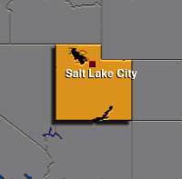

Utah Code 1953, Title 29, Section 29-1-1:

The Innkeeper or Hotel Keeper keeps on his premises a fireproof safe or vault, and gives notice to his guests by posting a copy of this section in a prominent or conspicuous place in the office of the hotel, or in the rooms occupied by guests, that he keeps for their use a fireproof safe or vault will not be liable for money, jewelry, documents, or other articles placed OR not placed within (the safe or vault) for more than $250.

Title 29, Section 29-1-2:

Property worth more than $250, Limitation of Liability, Special Arrangements, Theft by, or Negligence of, The Innkeeper or Servant.

The Innkeeper or Hotel Keeper shall not be obligated to receive from a Guest for deposit in the safe or vault, property exceeding a total value of $250, and shall not be liable for such property whether received or not. The Hotel may make a special arrangement with the Guest for receiving and depositing property in excess of $250 in their safe or vault. The Innkeeper can be held liable for this property (under the special arrangement) if the loss of the property is caused by the theft or negligence of the Innkeeper or his employee.

Title 29, Section 29-1-3:

The liability of an Innkeeper for loss of or injury to personal property placed in his care by his guests shall be that of a “depositary for hire”. Such liability shall not exceed $150 for each trunk and it’s contents, $50 for each valise, suitcase or other hand luggage and contents, and $10 for each box, bundle or package and contents so placed in his care. The Innkeeper can assume greater liability if he has consented to in writing to the Guest.

